Minutes 13/02/2019

Chairman: Dylan

Secretary: Tar

**Feedback on the description document**

-Data manipulation: store data and retrieve it

-Specify what makes our app unique (and better than others available)

Discussed changes:

-Decided on name: Yoke

-Data manipulation: Store all data in the app, but send prompts to computer for creating macros (I.e. the computer sends data back)

**Requirements document**

Check using:

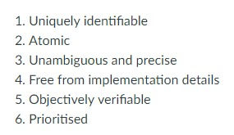

To be checked by someone else that didn’t create them

**Interface document**

mockups with brief descriptions of what can be seen (their interactions)

**Planning document**

add soft deadlines, divide who works on what implementation section

**Feedback on documents**

Description document and requirements: send today,

UI document: possibly send on friday

Send everything through email, not canvas

Next chairman: Yeochan

Next secretary: Dylan